Princess Sumaya University for Technology

King Abdullah II Faculty of Engineering

Electrical Engineering Department



|  |
| --- |
| **Smart Band** |

|  |  |  |  |
| --- | --- | --- | --- |
| *Authors:* |  |  | *Supervisor:* |
| Faris Ayyash  Hamza Abu Haweelah | 20190276  20160427 | Computer engineering  Power engineering | Dr. bilal sababha |

*January 23, 2023*

***Abstract***

*The Smart Band is an advanced device that can help anybody to accurately monitor and take care of their heart rate and oxygen level in the blood to maintain a healthy lifestyle. The band can detect and measure the heart rate and oxygen level in the blood and send the data via Bluetooth to the central system. The system can calculate the average of the data received and display it on an LCD and detect any unexpected event, in which an alarm system will start and alert the person wearing the smart band.*

Table of Contents

1 Introduction 2

1.1 Theory 2

2 Procedure and Methods 2

3 Results and Discussions 2

3.1 Figures 3

3.2 Tables 3

4 Conclusions 3

5 References 3

# Introduction

The project consists of an alarm system and display unit and a smart band that can read and send date to the alarm system serially via Bluetooth. In the regular conditions the alarm system unit will calculate the average of the data received and display them on the LCD. If any unexpected event happened to occur the alarm system will activate a PWM powered speaker that will vary in sound depending on the state of the situation, also a fan powered with an NMOS will start working.

## Theory

Laboratory experiments are designed to implement a theory. Therefore, this section aims to brief the relevant theory. While writing this section you would probably need to include equations. The following subsection gives some guidelines on how to write an equation.

# Procedure and Methods

Alarm system:

The alarm system is composed of aPIC16F877A microcontroller, an LCD, a Bluetooth module, a speaker, a 12V fan, 2x lithium 18650 3.7V. 2x Power NMOS, DC step up from 7.8V to 12V, custom PCB, and potentiometer.

The PIC will receive the data serially on a 2400 baud rate via Bluetooth. After displaying the average values of the heart rate and the oxygen level on the LCD the PIC will compare the averages to the default values, then it will act according to the results of the comparisons.

Smart Band:

The smart band is composed of an Arduino mini pro, a Bluetooth module, MAX30100 oxymeter, DC step up from 3.7V to 5V, charging board, custom PCB, and LIPO battery.

The Smart Band will read the sensor and then send the values serially via Bluetooth.

In order for the data to be sent and received correctly a 4byte protocol was made that consists of a start byte named “magic1”, the heart rate byte, the oxygen percentage byte, and finally the stop byte named “magic2”.

# Results and Discussions

The LCD is connected to PORTB of the PIC, the Bluetooth module is connected to the serial pins of PORTC, pin6 and pin7, the fan is connected to the CCP pin of PORTC, pin2, and the gate of the NMOS is connected to pin6 on PORTD, as shown on FIGURE(1).

As for the Smart Band the sensor is connected to the following pins: A4, A5, pin3. The master Bluetooth module is connected to pin0 and pin1, which are the RX and TX pins, as shown on FIGURE(2).

## Figures

## Tables

Table 1 heart rate ranges

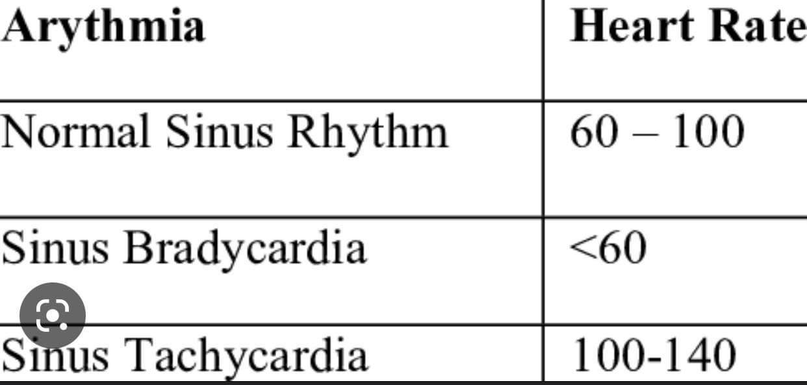

# Conclusions

The making of embedded systems are very complicated and require a lot of expertise and hard work for a project to become true. One of the key elements to build a successful system is planning ahead and step by step debugging.

# References

|  |  |
| --- | --- |
| [1] | "IEEE Editorial Style Manual," 2017. [Online]. Available: https://www.ieee.org/documents/style_manual.pdf. |
| [2] | G. Masters, Renewable and Efficient Electric Power Systems, Wiley-IEEE Press, 2013. |
| [3] | "www.digikey.com," [Online]. Available: https://www.digikey.com/schemeit/project/. [Accessed 23 November 2017]. |